### 

# **Magnetic Force** **on Electric Current in Magnetic Field**

**Pre-lab questions**

1. What is the goal of this experiment? What physics and general science concepts does this activity demonstrate to the student?
2. What is an expression for the magnetic force on a current carrying wire?
3. Suppose the electric current in a wire is pointed due north while it is in a magnetic field pointing due east. What is the direction of the magnetic force on the current carrying wire?
4. Suppose the electric current *I* in a wire is directed due north while it is in a magnetic field *B* pointing the same direction. What is the magnitude of the magnetic force on the current carrying wire?

The goal of this experiment is to help understand how a magnetic field interacts with moving electric charges in the form of an electric current. The magnetic force on the electric current is not measured directly. Instead, the Newton’s 3rd law reaction force on the magnet is measured.

**Introduction**

## Summary of relevant concepts:

## A current carrying wire in a magnetic field experiences a force that is usually referred to as a magnetic force.

The magnitude and direction of this force depends on four variables:

1. the magnitude of current *I*
2. the length of the wire *L*
3. the magnitude of magnetic field *B*
4. the angle *θ* between the magnetic field and the direction of the current in the wire.

The magnitude of the magnetic force on current *I* can be expressed by the equation:

*F = I L B* sin*θ*

If the current in a wire, *I*, is perpendicular to the magnetic field, *B*, thensin*θ =* 1 and the magnetic force:

*F = I L B*(1)

The direction of magnetic force *F* can be determined by using the right–hand rule, illustrated in the figure below.

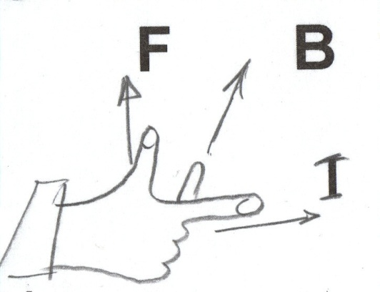

Figure 1. The Right-Hand Rule

If current *I* is passing through a conductor of known length *L*, located in a magnetic field *B*, the force *F* exerted on the conductor can be measured using a quadruple-beam balance. (Actually, the reaction force – Newton’s 3rd law – on the magnet will be measured.) If the force is measured for several known currents and then plotted as a function of current, the slope of the resulting curve is the product *B* sin *θ*. Once the direction of the magnetic field is also known, this slope can be used to determine the magnitude *B* of the magnetic field.

The goal of the experiment is to evaluate the magnetic force acting on a current currying conductor placed in a magnetic field of unknown strength but known direction, and to find experimentally the magnitude of this magnetic field. (A typical household magnet has a magnetic field on the order of $1×{10}^{-2}$ Tesla.)

**Equipment:**

The Lab Stand, the Main Unit, Current Loops set, the Magnet Assembly, a quadruple-beam balance, adjustable DC power supply, DC ammeter, ruler, connecting wires.

## Experiment

## Force versus Current

1. Set up the apparatus as shown in Figure 2 below. For this:

- mount the Main Unit on the Lab Stand

* select a Current Loop and plug it into the ends of the arms of the Main Unit with the foil extending down
* place the Magnet Assembly on a balance
* position the lab stand so the horizontal portion of the conductive foil on the Current Loop passes evenly through the pole region of the magnets; the Current Loop shouldn’t touch the magnets.

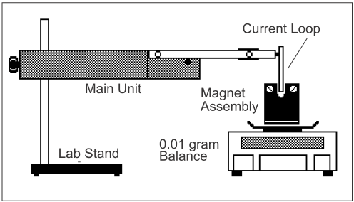Figure 2. The apparatus set up.

1. Measure the length of horizontal portion of the Current Loop that passes through the region of the magnet poles and record it in the Table 1 provided below.
2. Connect the power supply and ammeter to the Main Unit as shown in Figure 3.

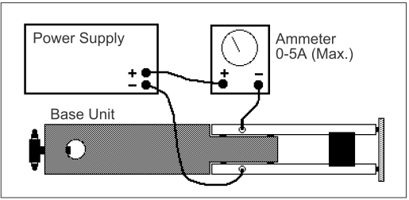

Figure 3. Wiring connections

1. Determine the mass of the magnets with NO current flowing. Record this value in the column under “Mass” in Table 1 provided below.
2. Set the current to 0.25 A by adjusting the power supply. Determine the new “mass” of the magnet assembly. Record this value under “Mass” in Table 1. (Reduce current to zero when not taking a measurement.)
3. Subtract the mass value with the current flowing from the value with no current flowing. Record the difference as the “Change in Mass”.
4. The reaction to the force between the magnetic field and the current-carrying conductor is given by equation*: F = m g*. To determine the actual value of force (in Newtons), multiply each reading of the difference in masses in grams by acceleration due to gravity which is $g = 9.8 ×{10}^{-3}$ Newtons/gram.

Record the results of calculation in the Table as the “Force”.

1. Increase the current in 0.25-A increments each time repeating steps 5 – 7. Increase the current up to a maximum of 2 A.

### **Table 1 for Trial 1** Length of conductor *L*1 = (m)

|  |  |  |  |
| --- | --- | --- | --- |
| Current (A) | “Mass” (gm) | “Change” in mass from zero current (gm) | Force () |
| 0 |  |  |  |
| 0.25 |  |  |  |
| 0.5 |  |  |  |
| 0.75 |  |  |  |
| 1.0 |  |  |  |
| 1.25 |  |  |  |
| 1.5 |  |  |  |
| 1.75 |  |  |  |
| 2.0 |  |  |  |

Note: You will need to use *g* = 9.8×10-3 N/gm to calculate force in Newtons!

1. Plot a graph of Magnetic Force (vertical axis) versus Current in the Conductor (horizontal axis).
$$Slope = \frac{∆F}{∆I}$$

2. Using the Slope and the measured length of the conductor *L*1, determine the magnetic field *B*1 using the Equation 1 in the introduction:

*B*1 *=*

1. Reverse the polarity of current (an easy way to do it is to reverse the polarity of the connections to the current loop) and repeat steps 4 – 10, recording data in Table 2.

### **Table 2 for Trial 1, reverse polarity** Length of conductor *L*1 = (m)

|  |  |  |  |
| --- | --- | --- | --- |
| Current (A) | “Mass” (gm) | “Change” in mass from zero current (gm) | Force () |
| 0 |  |  |  |
| 0.25 |  |  |  |
| 0.5 |  |  |  |
| 0.75 |  |  |  |
| 1.0 |  |  |  |
| 1.25 |  |  |  |
| 1.5 |  |  |  |
| 1.75 |  |  |  |
| 2.0 |  |  |  |

Note: You will need to use *g* = 9.8×10-3 N/gm to calculate force in Newtons!

1. Plot a graph of Magnetic Force (vertical axis) versus Current in the Conductor (horizontal axis).
2. Determine the slope of your plot:
$$Slope = \frac{∆F}{∆I}$$

3. Using the Slope and the measured length *L*1 of the conductor, determine the magnetic field *B*2 from the Equation 1:

*B*2 =

1. Repeat the experiment with original polarity for another Current Loop.

Measure the length of horizontal portion of the Current Loop that passes through the pole region of the magnets and record it in the Table 3 provided below.

1. Repeat steps 4 – 10 for a new loop and recording data in Table 3.

### **Table 3 for Trial 2, new current loop length:** Length of conductor *L*2 = (m)

|  |  |  |  |
| --- | --- | --- | --- |
| Current (A) | “Mass” (gm) | “Change” in mass from zero current (gm) | Force (N) |
| 0 |  |  |  |
| 0.25 |  |  |  |
| 0.5 |  |  |  |
| 0.75 |  |  |  |
| 1.0 |  |  |  |
| 1.25 |  |  |  |
| 1.5 |  |  |  |
| 1.75 |  |  |  |
| 2.0 |  |  |  |

Note: You will need to use *g* = 9.8×10-3 N/gm to calculate force in Newtons!

1. Plot a graph of Magnetic Force (vertical axis) versus Current in the Conductor (horizontal axis).

1. Determine the slope of the graph: $Slope = \frac{∆F}{∆I}$ Using the Slope and the measured length of the conductor *L2*, determine the magnetic field *B*3 from the Equation 1:

*B*3 =

1. Record your findings of magnetic field of the horseshoe magnet assembly in Table 4, calculate the average $B_{av}$ and percent deviation of each result from the average. Given the information in the introduction, do these seem like reasonable values? If not, check your calculations and unit conversions.

Table 4

*B* Δ*B* percent $\%=\frac{∆B}{B}$ 100%

Tesla Tesla %

*B*1 =

*B*2 =

*B*3 =

=

**Conclusions & Sources of Errors in final report.**